LIMESTONE (Calcium Carbonate)

About
Limestone ek natural stone hai jo calcium carbonate (CaCO3) se bana hota hai.
Ye samundar ke shells aur minerals se banta hai.

Colour
- White
- Light Grey
- Kabhi kabhi yellowish
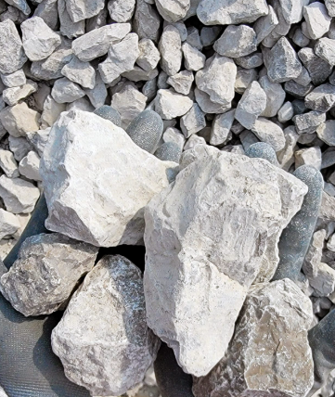
White colour Lime stone
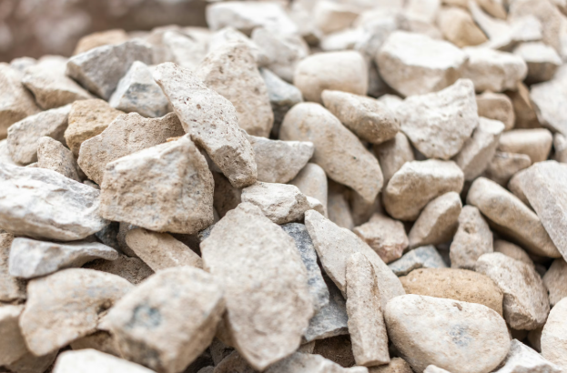
Yellow colour Limestone
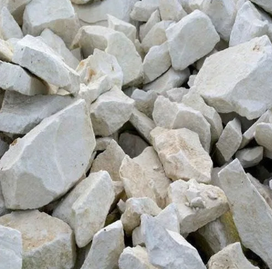
Light Grey Colour Limestone

Specifications
- CaCO3: 85% – 98%
- MgCO3: 0% – 5%
- SiO2: 1% – 10%
- Color: White / Grey
- Form: Lumps / Powder

Size
- 0–5 mm (Powder)
- 5–20 mm
- 20–50 mm
- Custom size available

Use (Application)
- Cement industry (main use)
- Steel plant (iron cleaning)
- Construction (road, building)
- Agriculture (soil improve)
- Chemical industry

Calcined Limestone kya hota hai?
Calcined limestone ka simple meaning hai:
Limestone (CaCO₃) ko high temperature (900–1100°C) par heat karke jo product banta hai, use calcined limestone ya quicklime kehte hain.

Chemical change:
CaCO₃ (Limestone) → CaO (Quicklime) + CO₂

Purity kya hoti hai?
Calcined limestone (quicklime) ki purity raw stone aur kiln process par depend karti hai:

Industrial grades:
- High purity: 90% – 95% CaO
- Standard industrial: 85% – 90% CaO
- Low grade: 75% – 85% CaO
Impurities:
- SiO₂ (silica)
- MgO (magnesia)
- Al₂O₃
Steel & ferro industries me high CaO (90%+) preferred hota hai

Kahan-kahan use hota hai?

1. Steel Industry
- Steel purification (impurities remove karna)
- Slag formation

2. Ferro Alloys (Ferro Silicon etc.)
- Furnace me impurities absorb karta hai
- Slag control ke liye use hota hai

3. Chemical Industry
- Calcium compounds banane me

4. Water Treatment
- Water ko clean aur neutralize karne ke liye

5. Cement Industry
- Cement manufacturing me raw material

6. Agriculture (limited use)
- Soil pH balance karne ke liye
where different limestone lump sizes are used
Size Range | Type | Where It Is Used | Purpose
0–5 mm | Powder / Fines | Cement industry, paints, agriculture, FGD | Filling, soil treatment, pollution control
5–20 mm | Small chips | Poultry feed, construction, chemical industry | Calcium source, mixing, small processes
20–50 mm | Medium lumps | Steel plants, chemical plants | Flux material, chemical reactions
50–100 mm | Large lumps | Kilns, furnaces | Lime production (better heat flow)
100–300 mm | Very large lumps | Shaft kilns | Used for making quicklime

India me kaha milta hai
India me limestone yaha milta hai:
- Rajasthan (sabse best quality)
- Madhya Pradesh
- Chhattisgarh
- Gujarat
- Andhra Pradesh

World me kaha milta hai
- India
- China
- Vietnam
- Turkey
- UAE

Purity Difference (India Usa Vietnam Turkey UAE China)

India
- CaCO3: 90%–98% (Rajasthan best)
- Quality: High purity
- Cost: Low
- Supply: Bulk me available
- Best for: Cement, Steel, Export
India ka material cheap + high quality + bulk hota hai

China
- CaCO3: 85%–95%
- Quality: Medium to high
- Cost: Medium to high
- Form: Mostly powder
China me processing achhi hoti hai, but cost jyada padta hai

Vietnam
- CaCO3: 90%–97%
- Quality: Good white limestone
- Cost: Medium
Mostly filler aur powder industry ke liye use hota hai

Turkey
- CaCO3: 85%–95%
- Quality: Good
- Cost: Medium
Europe market me zyada supply karta hai

UAE
- CaCO3: 80%–90%
- Quality: Medium
- Cost: High (import bhi karte hain)
UAE khud bhi import karta hai India se

Why Other Countries Buy from India
- Price cheap hai
- High purity material milta hai
- Bulk quantity available
- Export easy (ports se)
- Reliable supply

WHY BUYERS CHOOSE US

✔ Long term supply relationship focus, not only one time trade
✔ Buyer requirement ke hisaab se grade aur size customization
✔ Loading se pehle proper quality checking & inspection
✔ Time pe shipment dispatch ki full responsibility humari
✔ Port handling aur safe storage arrangement available
✔ Urgent requirement ke liye fast supply arrangement
✔ Full transparency with proper documentation in every shipment

PAYMENT & BUSINESS TERMS
✔ Payment terms flexible hai (buyer trust aur volume ke hisaab se)
✔ Advance / LC / partial payment options available
✔ Long term buyers ke liye better pricing aur priority supply

OUR HANDLING SYSTEM
✔ Hum already badi companies ko regular supply kar rahe hain
✔ Transport se leke port delivery tak complete handling hum karte hain
✔ Buyer ko kisi bhi logistics ya transport problem ka tension nahi hota
✔ Agar material import hota hai to port pe safe storage me rakha jata hai

SIMPLE LINE
Hum sirf supplier nahi hain, hum complete supply chain partner hain — mine se leke final delivery tak sab smooth aur reliable tarike se manage karte hain.

INDIA vs OMAN LIMESTONE COMPARISON
Specification | India Limestone | Oman Limestone
CaCO3 Content | 85% – 98% (Rajasthan up to 98%) | 90% – 97%
Purity | High purity (varies by mine) | Consistent good purity
Colour | White / Grey / Yellowish | Mostly light grey / white
Form | Lumps + Powder | Mostly Lumps
Silica (SiO2) | 1% – 10% | 1% – 5% (generally lower)
Moisture | Low to medium | Low
Availability | Very large reserves, multiple states | Limited reserves but stable
Cost | Low cost | Medium to high cost
Mining Cost | Low | Higher than India
Export Advantage | Very competitive pricing + bulk supply | Good quality but higher price
Main Use | Cement, Steel, Construction, Chemical | Cement, Steel, Industrial use

Final Comparison
Country | Quality | Price | Supply
India | High | Low | High
China | Medium | Medium/High | High
USA | Very High | Very High | Low export
Vietnam | Good | Medium | Medium
Turkey | Good | Medium | Medium
UAE | Medium | High | Low

